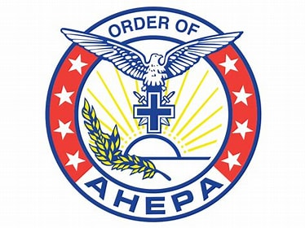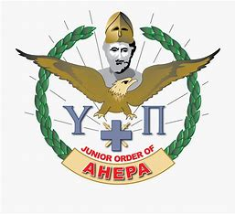

District #24 Scholarship Program

The Order of AHEPA and Daughters of Penelope Joint Scholarship of $1500 is awarded to:
- a student currently enrolled in a post graduate program. Undergraduate marks will be used to determine eligibility.
- a student enrolled in an undergraduate program at a post-secondary institution (university, college, or technical school) with a high school average of 80% or higher will be considered if there is no applicant in a post graduate program,
- a member of the AHEPA Family of District 24(Manitoba, Saskatchewan or Alberta) or the children or grandchildren of a member in good standing of the AHEPA Family of District #24

The William H. Girgulis Memorial Scholarship of $1500 is awarded to:
- a member in good standing of the Maids of Athena or Sons of Pericles in District #24
- a student enrolled in an undergraduate program at a post secondary institution (university, college, or technical school)
- a student with a high school average of 80% or higher.

NOTE: The marks used to determine the average will be the senior matriculation level academic subjects of Math, Social Studies, English, the highest Science mark and the highest of another academic subject.

NOTE: See note above regarding marks.

- Scholarship applications must be received at the address below no later than May 1 for consideration.
- Department of Education official transcripts must be forwarded directly from the Department of Education to:

Vasilia (Celia) Kachmarski
26-72 Millside Drive SW
Calgary, AB T2Y 3G8

- All Scholarships are awarded at the annual District Convention.
- Payment of scholarships will be made directly to the recipient. Recipients are only eligible to win a scholarship once.
- Candidates re-applying must have official transcripts forwarded directly to the name listed above.

Scholarship Application Form

Full Name: ______________________________________________________________

Address: ______________________________________________________________

City: _______________ Province: __________Postal Code: ______________

Phone #: _______________ S.I.N. ______________ Email: _____________________

Name and address of high school from which you graduated:

______________________________________________________________________

Name of post secondary institution you are presently attending:

______________________________________________________________________

Current Course of Study: ______________________________________________

Official Department of Education high school transcripts are required. (See page 1)

NOTE: If you are in graduate school please provide:

Name of graduate institution you are presently attending:

_____________________________________________________________________

Current Course of Study: _____________________________________________

Official undergraduate transcripts are required.

FOR SCHOLARSHIP COMMITTEE ONLY

Scholarship Awarded: _______________________________________________

Date: _______________________________________________________________

Verification of Membership

If you are a member in good standing of the Sons of Pericles or Maids of Athena:

Name of Chapter: _____________________ City: ______________________

Signatures: ____________________________ ___________________________
Chapter President Secretary (verifies standing)

___________________________ ___________________________
Applicant’s signature Date

________________________________________________________________________

If you are NOT a member of the Sons of Pericles or Maids of Athena, then the following must be filled in for one of your parents/ grandparents who are members in good standing of the Order of AHEPA or Daughters of Penelope.

Member’s Name: _____________________________________________________

Relation to applicant: _________________________________________________

Name of Chapter: __________________________ City: ____________________

Signatures: _____________________________ _____________________________
Chapter President Secretary (verifies standing)

_____________________________ _______________________
Applicant’s Name Date

Deadline for applying is May 1

Reviewed/updated June 2024

